CSE5006 Assignment 1

### **Plagiarism**

**This is assignment must be completed individually, not in groups**. You are welcome to discuss problems with fellow students, but the work that you submit must be your own. Don't try to plagiarise, it's extremely obvious and will only serve to get you into trouble. That's not any fun for you or for us.

### **Due Date**

**This assignment is due on Friday, 26 August 2022, 11:00 PM.** Penalties are applied to late assignments (accepted up to 5 days after the due date only). See the departmental Student Handbook for details.

### **Submission Details**

* Zip up everything in your project directory as well as word document or PDF of current document in which the required boxes (code and screenshots) have been filled in.
* Submit your zipped file via LMS

**Your Student ID: <Type Your Student ID Here>**

**Your Full Name: <Type Your Full Name Here>**

**Task 1 (10 marks)**

1.a

$ git init

1.b

1.c

$ git add .

$ git commit -m “Initial commits”

$ git push origin master

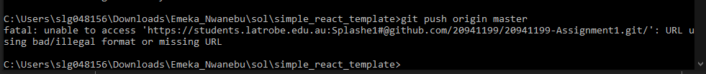

**Task 2 (10 marks)**

Modified File Name/s: docker-compose.yml

Modified Line/s: 10

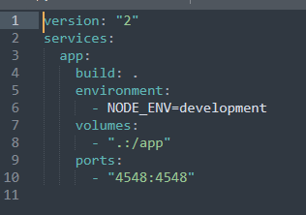

**Task 3 (25 marks)**

<script>

//put your function here

const buttons = document.getElementsByTagName("input");

var buttonsCount = buttons.length;

for (var i = 0; i <= buttonsCount; i += 1) {

buttons[i].onclick = function(e) {

document.getElementById('clicked').innerHTML = this.id;

document.getElementById(this.id).style.background = "blue";

};

}

</script>

**Task 4 (35 marks)**

<script>

//put your function here

// counter

let counter = 0;

const buttons = document.getElementsByTagName("input");

var buttonsCount = buttons.length;

for (var i = 0; i <= buttonsCount; i += 1) {

buttons[i].onclick = function(e) {

counter++

document.getElementById('clicked').innerHTML = this.id;

document.getElementById('moved').innerHTML = counter;

//check if the number is even

if(counter % 2 == 0) {

//console.log("The number is even.");

document.getElementById(this.id).style.background = "blue";

document.getElementById(this.id).value = "X";

}

// if the number is odd

else {

//console.log("The number is odd.");

document.getElementById(this.id).style.background = "red";

document.getElementById(this.id).value = "0";

}

};

}

</script>

**Task 5 (25 marks)**

Modified File Name/s: package.json

Modified Line/s: 15 - “set PORT=4548 && react-scripts start”

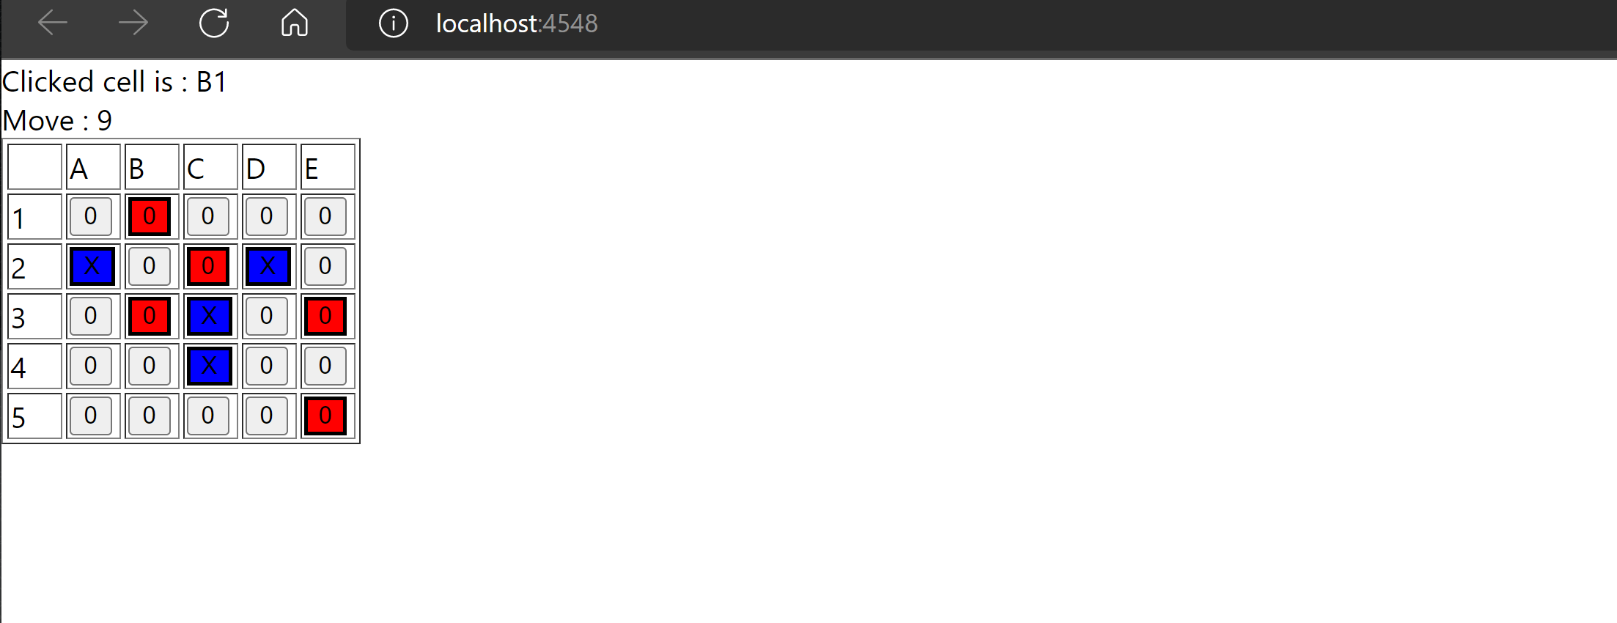

Screenshot for Repository and contributor

